ANALYSE OF REDDIT 2008-12-17

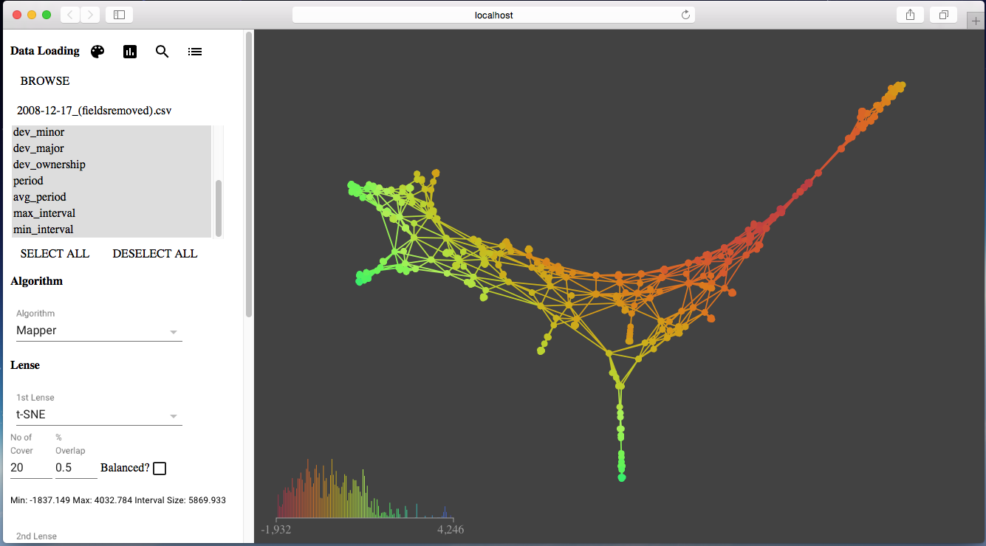

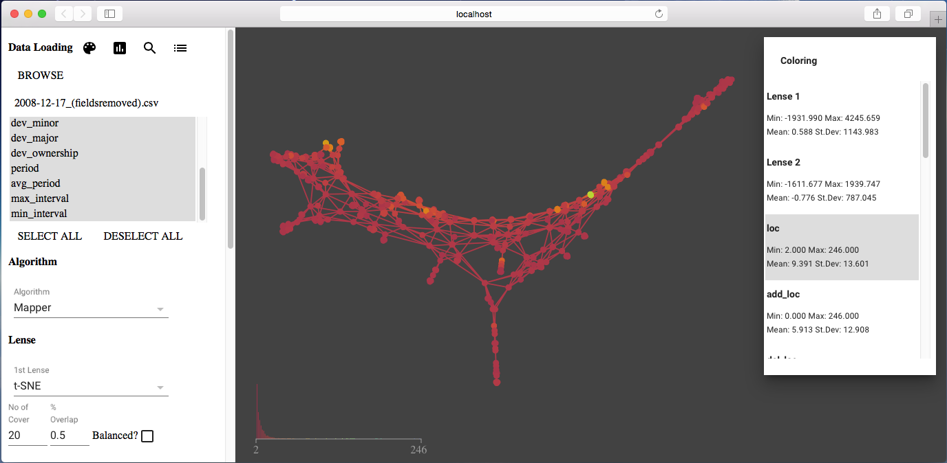

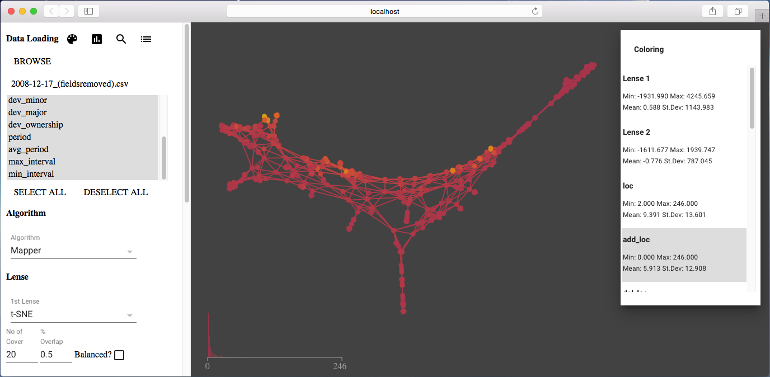

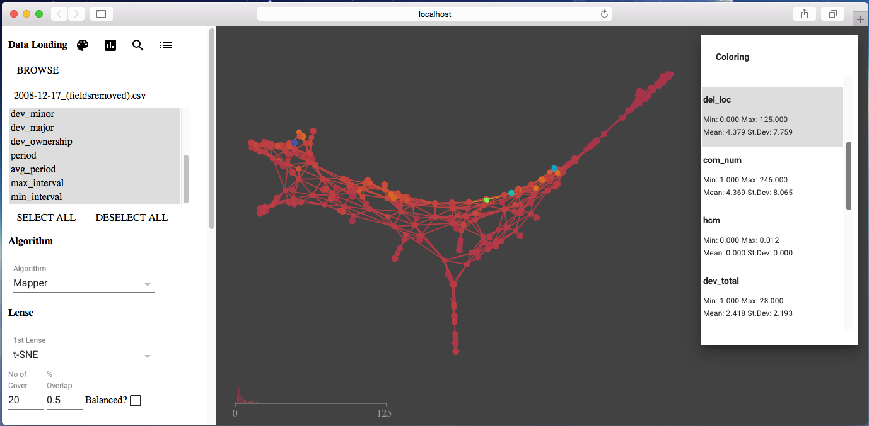

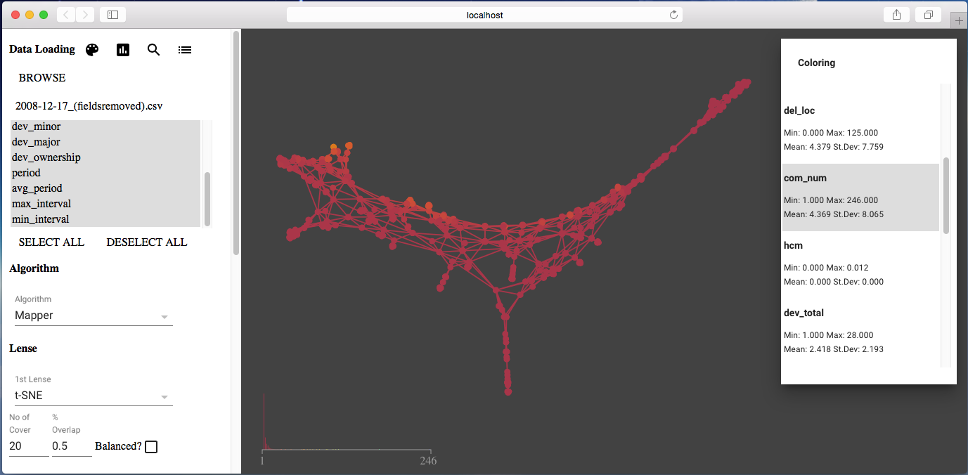

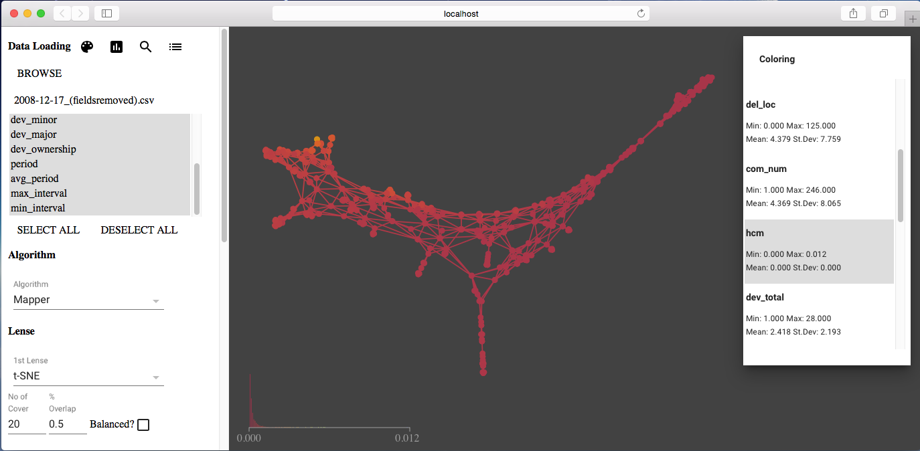

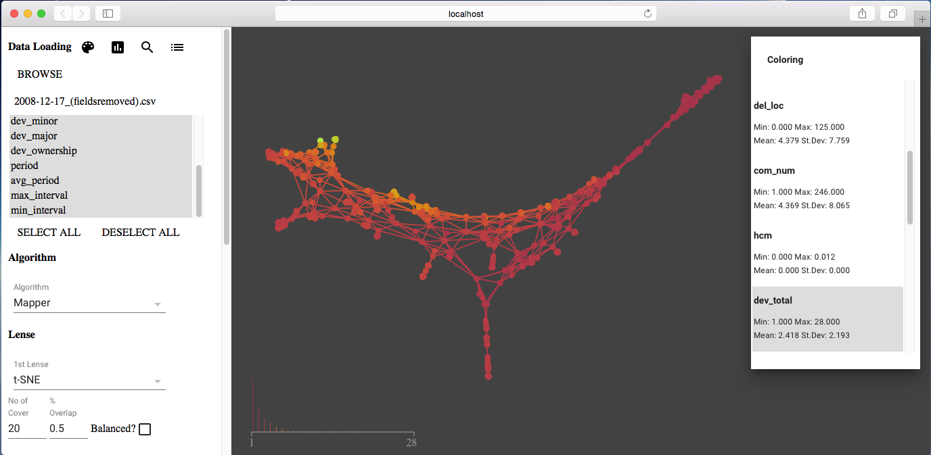

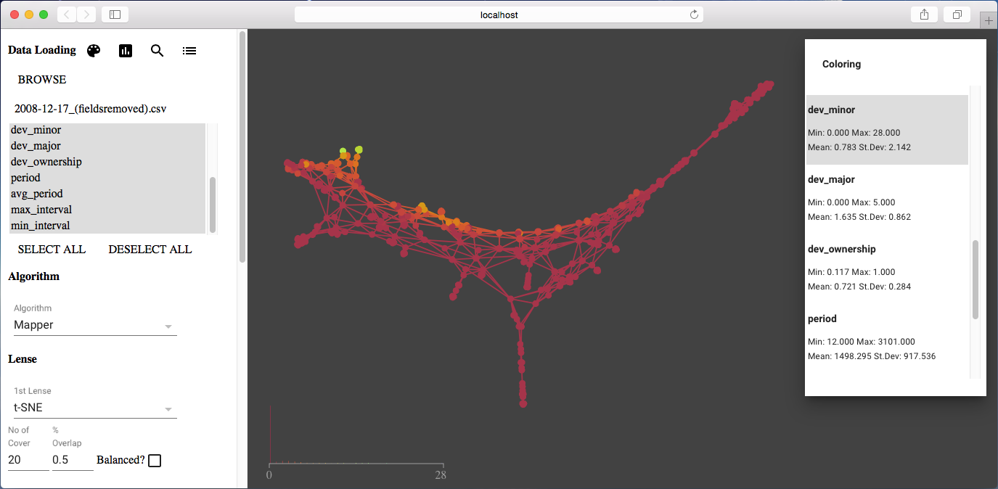

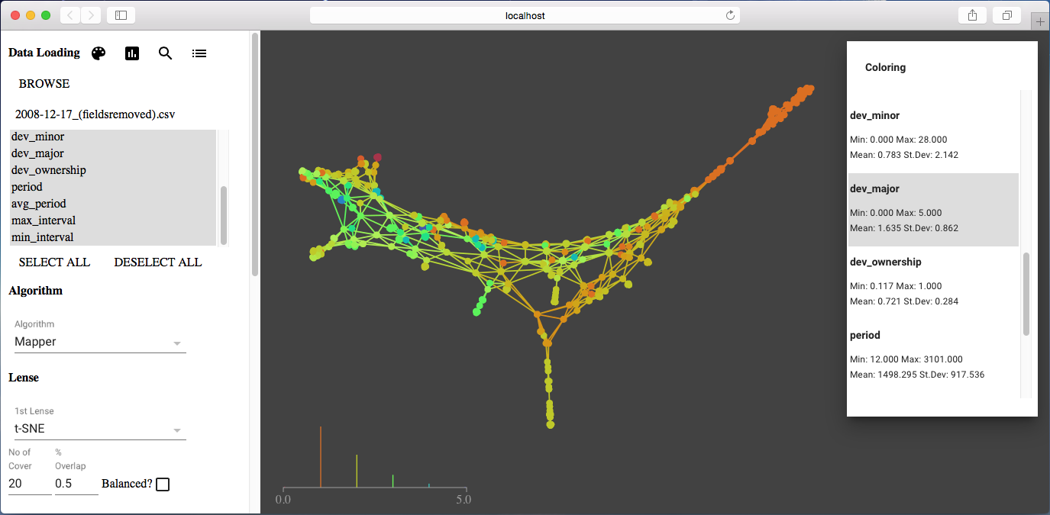

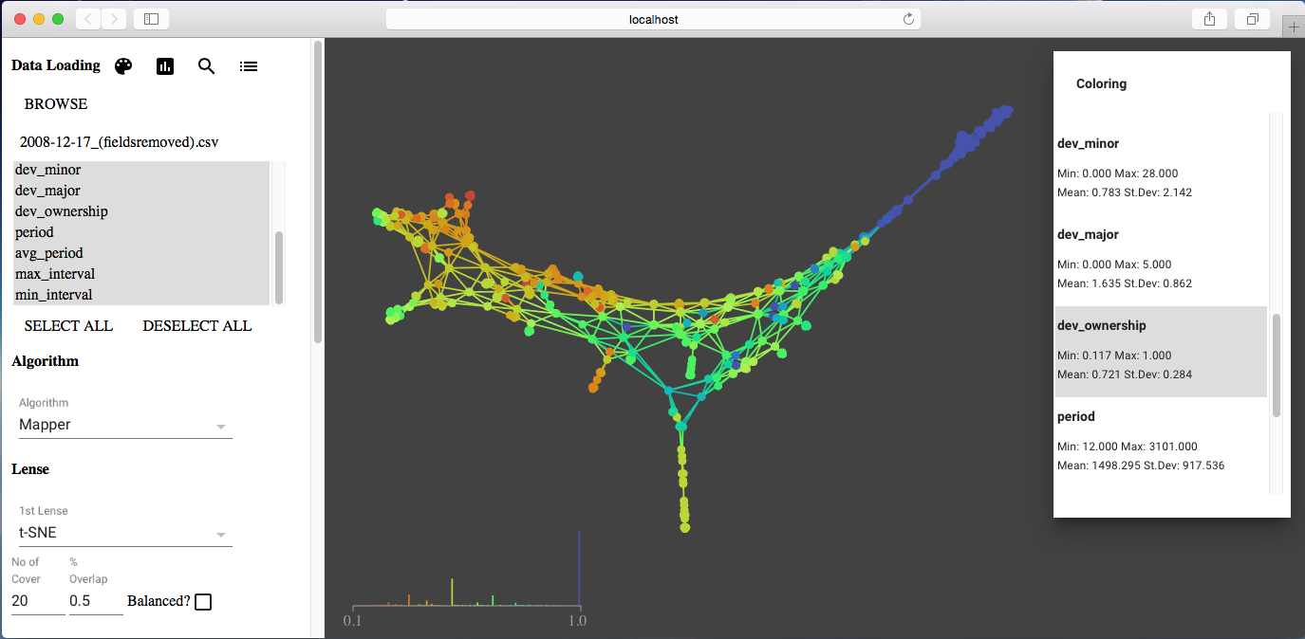

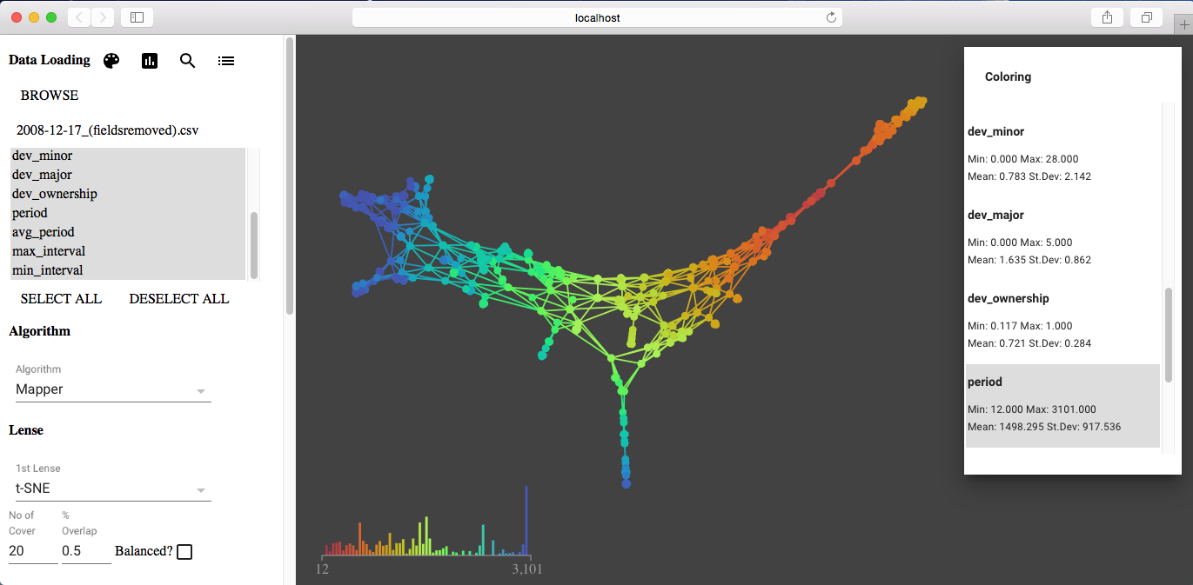

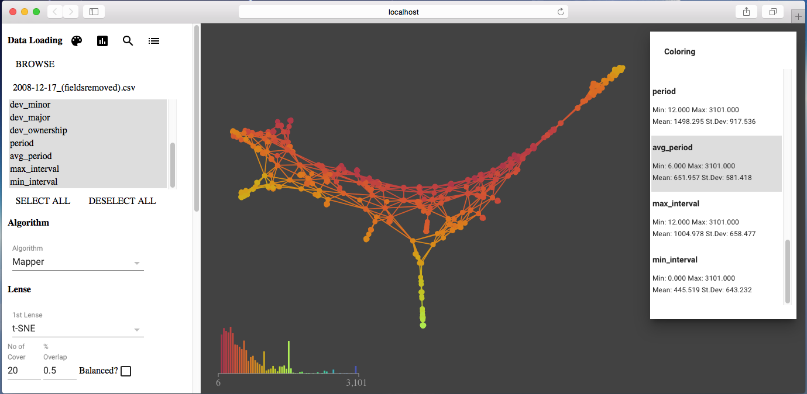

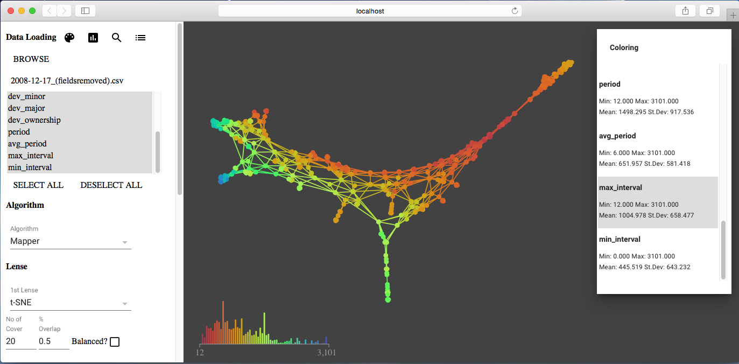

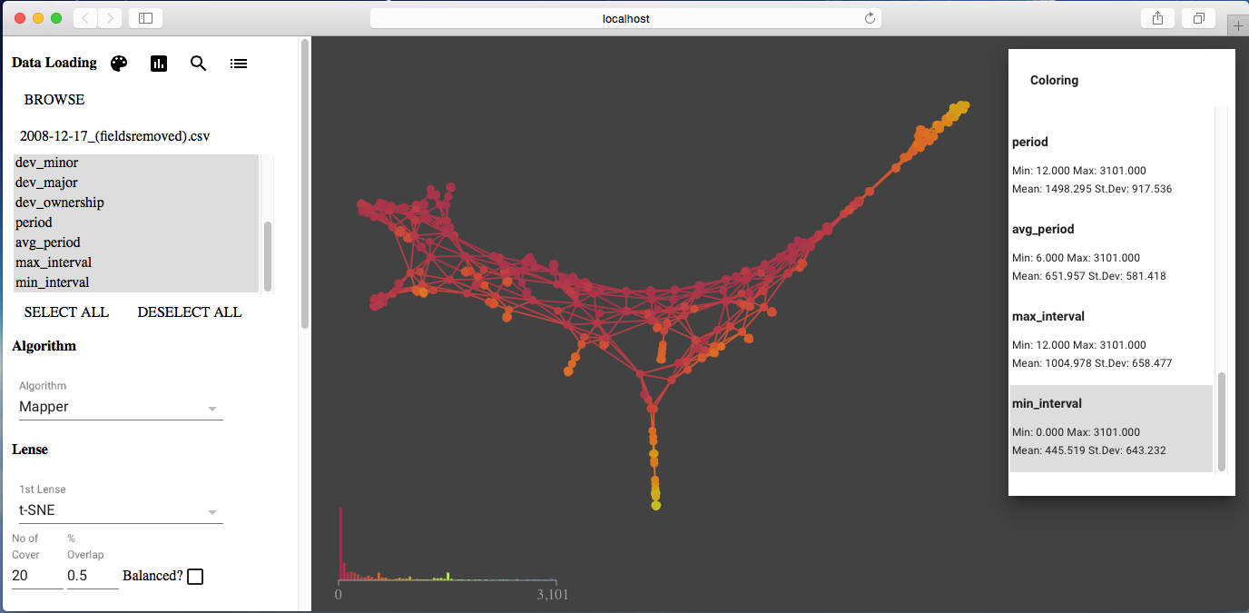

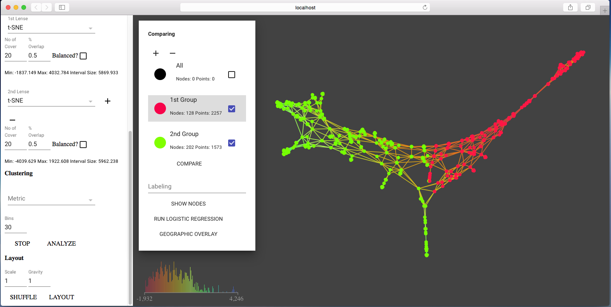

#### Analysis Result

|  |  |  |  |  |  |  |  |  |
| --- | --- | --- | --- | --- | --- | --- | --- | --- |
| **Variables** | **Group 1 min** | **Group 2 min** | **Group 1 mean** | **Group 2 mean** | **Group 1 median** | **Group 2 median** | **Group 1 max** | **Group 2 max** |
| loc | 2.0 | 2.0 | 8.872 | 12.099 | 6.0 | 7.0 | 106.0 | 246.0 |
| add_loc | 0.0 | 0.0 | 4.772 | 10.891 | 2.0 | 6.0 | 61.0 | 246.0 |
| del_loc | 0.0 | 0.0 | 4.004 | 7.474 | 2.0 | 5.0 | 106.0 | 125.0 |
| com_num | 1.0 | 2.0 | 2.95 | 8.36 | 2.0 | 5.0 | 34.0 | 246.0 |
| hcm | 0.0 | 0.0 | 0.0 | 0.001 | 0.0 | 0.0 | 0.002 | 0.012 |
| dev_total | 1.0 | 1.0 | 1.879 | 4.086 | 1.0 | 3.0 | 10.0 | 28.0 |
| dev_minor | 0.0 | 0.0 | 0.307 | 1.979 | 0.0 | 0.0 | 9.0 | 28.0 |
| dev_major | 0.0 | 0.0 | 1.571 | 2.107 | 1.0 | 2.0 | 5.0 | 5.0 |
| dev_ownership | 0.167 | 0.117 | 0.772 | 0.494 | 1.0 | 0.444 | 1.0 | 1.0 |
| period | 12.0 | 1099.0 | 808.077 | 2276.597 | 708.0 | 2403.0 | 1987.0 | 3101.0 |
| avg_period | 6.0 | 12.0 | 380.962 | 443.825 | 310.0 | 387.0 | 993.0 | 1498.0 |
| max_interval | 12.0 | 166.0 | 583.294 | 1140.24 | 568.0 | 1033.0 | 1788.0 | 2877.0 |
| min_interval | 0.0 | 0.0 | 234.938 | 74.329 | 130.0 | 10.0 | 960.0 | 1146.0 |